Project Description

Name: Brazilian E-Commerce Public Dataset by Olist

Problem Statement:
- Olist is an e-commerce platform that connects small and medium-sized businesses to customers. The platform operates as a marketplace, where merchants can list their products and services and customers can browse and purchase them online.

- As a new data analyst at Olist Team, you have been tasked with analyzing the most in-demand products, identifying the most active sellers and their impact on overall sales, and examining delivery performance to determine its relationship with low ratings. The goal of this analysis is to provide comprehensive insights to boost sales and enhance the customer experience.

Possible Impact of Your Analysis:
- This analysis can drive strategic decision-making by identifying the most in-demand products and top-performing sellers, thereby enhancing marketing efforts and optimizing inventory management across categories. Sellers can refine their strategies by understanding key success factors, such as product attributes and customer preferences, to better align with market demand. Improving delivery performance by addressing delays associated with low ratings can significantly enhance customer satisfaction and loyalty. Additionally, leveraging insights from the analysis can support more accurate sales forecasting and the development of effective pricing strategies, contributing to sustainable growth and the achievement of Olist's business objectives.

Dataset(s):
(Include information on where your dataset is from, the license for using the dataset, and a brief description of the variables included in your dataset.)

Source: https://www.kaggle.com/datasets/olistbr/brazilian-ecommerce/data
License : CC BY-NC-SA 4.0

description of the variables: Brief_Description_of_Variables.docx

Project Scoping Document

Business Problem
- E-commerce has become a vital part of the global retail industry, with platforms like Olist connecting small and medium-sized businesses to customers. However, the e-commerce sector faces challenges in predicting customer demand, optimizing inventory, and improving delivery performance.

- Olist seeks to identify in-demand products, assess seller performance, and address delivery delays, which are often associated with lower customer ratings. These issues impact both customer satisfaction and overall sales.

Business Impact
This analysis provides actionable insights to enhance sales and customer experience:

- Optimizing inventory and marketing by identifying high-demand products. For example, this helps ensure that top-selling items are always in stock and allows for more effective, targeted marketing campaigns.

- Strengthening relationships with top sellers by recognizing their contributions to the platform and offering incentives to encourage continued high performance and reliability.

- Improving delivery performance by identifying and addressing delays that negatively impact customer reviews. Timely deliveries are key to ensuring a positive customer experience and encouraging repeat purchases.

- Enhancing pricing and promotion strategies by leveraging insights on customer behavior and sales trends.

By implementing these findings, Olist can drive higher sales, improve decision-making, and enhance overall platform efficiency.

Dataset(s)
Brazilian E-Commerce Public Dataset by Olist
Strengths: Contains information of 100k orders from 2016 to 2018 made at multiple marketplaces in Brazil
Weaknesses: Missing or incomplete data for certain sellers, customers, or product categories. Some reviews may not provide detailed insights.

Methods
- Variables : Key variables will include: order_status, review_score, product_category_name, price, product_id, seller_id, payment_value, order_purchase_timestamp and delivery_time.

- Analysis Methods:
  - Descriptive Analytics: Summarize key metrics such as total sales, average ratings, and number of orders.
  - Correlation Analysis: Explore the relationship between review scores and delivery performance.

  - Clustering: Group products or sellers with similar performance for targeted strategies.
  - Visualization: Display insights with charts for revenue, price distributions, and ratings.
  - Dashboard Development: Build a simple dashboard to showcase key insights for decision-makers.

Dashboard

This is a rough preliminary dashboard mockup and is likely to be adjusted or changed later
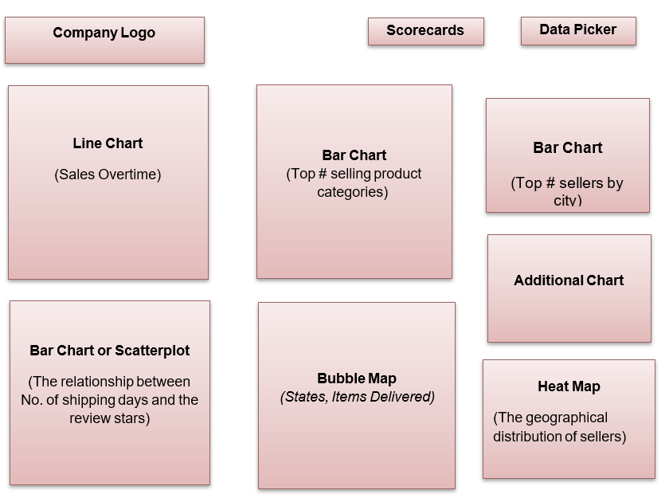

Milestones
- Identify characteristics of variables: Understand the nature of key variables such as order_status, review_score, product_category_name, etc.

- Clean data: Handle missing data, remove duplicates, and standardize data formats for analysis.

- Create visualizations: Develop charts and graphs to illustrate key insights.

- Show relationships between variables: Explore correlations and trends, such as the impact of delivery performance on low ratings.

- Create dashboard: Build an interactive dashboard to present findings (using Tableau, Looker Studio, or similar tools).
- Write final report: Summarize the analysis, methods, findings, and recommendations.

Timeline

Week | Tasks
Week 1 | - Explore initial dataset: Review data and identify additional dataset needs (e.g., marketing funnel).  - clean data Handle missing values and ensure data readiness.  - Identify variable characteristics: Understand key data properties for analysis.  - Envision final product: Define key metrics and expected insights.
Week 2 | - Create visualizations: Display key trends and insights through charts.  - Analyze relationships: Study links between variables like revenue  and reviews.  - Summarize findings: Use pivot tables for clear data presentation.
Week 3 | - Develop dashboard: Build an interactive dashboard to showcase insights.  - Write final report: Summarize analysis, findings, and recommendations.  - Review dashboard/report: Ensure accuracy and ease of use.

